RIVER LAMPREY

Lampetra ayresi

Status: Class 3. Watch List. Very little is known about river lamprey in California but given its dependence on the lower reaches of large, regulated rivers, it could disappear from most or all rivers in California under unfavorable conditions.

Description: The river lamprey is a small predatory species with spawning adults being about 17-18 cm TL. The oral disc is at least as wide as the head. The ‘teeth’ (horny plates) in the oral disc are conspicuous and pointed, they but can be blunt in spawning individuals. The middle cusp of the transverse lingual lamina has three large lateral (circumoral) plates on each side; the outer two have two distinct cusps, while the middle one has three. The supraoral plate has only two cusps that often appear as separate teeth, while the infraoral plate has 7-10 cusps. The eye width is 1 to 1.5 times the distance from the posterior edge of the eye to the anterior edge of the first branchial opening. The number of trunk myomeres averages 68 in adults and 67 (65-70) in ammocoetes. Adult river lampreys are dark on the back and sides and silvery to yellow on the belly with darkly pigmented tail. Ammocoetes have somewhat pale heads, a prominent line behind the eye spot, and a tail in which the center tends to be lightly pigmented (Richards et al. 1982).

Taxonomic Relationships: The river lamprey was described in 1855 by William O. Ayres from a single specimen collected in San Francisco Bay, as Petromyzon plumbeus. Because that name had already been given to a European lamprey, it was renamed, P. ayresi, in 1870. A careful redescription of the river lamprey by V.D. Vladykov and W.I. Follett (1958) demonstrated its distinctiveness. It is closely related to the Pacific brook lamprey (L. richardsoni) and the Kern brook lamprey (L. hubbsi), which apparently evolved independently from Pacific lampreys.

Life History: River lampreys have not been studied in California (Moyle 2002), so the information in this account is based on studies in British Columbia (Roos et al.1973, Beamish and Williams 1976, Beamish 1980, Beamish and Youson 1987).
Larval river lampreys, ammocoetes, start to transform into adults when they are about 12 cm TL, during summer. Metamorphosis may take 9-10 months, the longest known for any lamprey. Newly metamorphosed lampreys may aggregate immediately upriver from salt water and enter the ocean in late spring. Adults apparently only spend 3-4 months in salt water, where they grow rapidly, reaching 25-31 cm TL.
River lampreys prey on fishes in the 10-30 cm TL size range, but the most common prey seem to be herring and salmon. Unlike other species of lamprey in California, river lampreys typically attach to the back of the host fish, above the lateral line, where they feed on muscle tissue. Feeding continues even after the death of the prey. The effect of river lamprey predation on prey populations is has the potential to be large if both prey and predator are concentrated in small areas (Beamish and Neville 1995). River lampreys can apparently feed in either salt or fresh water, although a land-locked population may exist in upper Sonoma Creek (Wang 1986).
Adults migrate back into fresh water in the fall and spawn during the winter or spring months in small tributary streams, although the timing and extent of migration in California is poorly known. A gravid female collected at 250 km upstream of the mouth of the Eel River in May 1992 suggests long migrations are possible (Moyle, unpublished data). While maturing, river lampreys can shrink in length by about 20 percent. Adults create saucer-shaped depressions in gravelly riffles for spawning by moving rocks with their mouths. Fecundity estimates for two females from Cache Creek, Yolo Co., were 37,300 eggs from one 17.5 cm TL and 11,400 eggs for one 23 cm TL (Vladykov and Follett 1958). Adults die after spawning. Ammocoetes remain in silt-sand backwaters and eddies and feed on algae and microorganisms. The time river lampreys spend as ammocoetes is not known but it is probably 3-5 years, so the total life span is presumably around 6-7 years.

Habitat Requirements: The habitat requirements and environmental tolerances of spawning adults and ammocoetes have not been studied in California. Presumably, the adults need clean, gravelly riffles in permanent streams for spawning, while the ammocoetes require sandy to silty backwaters or stream edges in which to bury themselves, where water quality is continuously high and temperatures do not exceed 25°C.

Distribution: River lampreys occur in coastal streams from just north of Juneau, Alaska, down to San Francisco Bay. In California, they have been recorded from the Sacramento and San Joaquin Delta while migrating, tributaries to the San Francisco Estuary (Napa River, Sonoma Creek, Alameda Creek), and tributaries to the Sacramento and San Joaquin rivers (e.g. Tuolumne River, Stanislaus River, Cache Creek). In Oregon, there are no recent records of river lamprey and most older records are for the Columbia River basin (Kostow 2002). Likewise, they are known only from two large river systems in British Columbia, in the center of their range (Beamish and Nelville 1991).

Trends in Abundance: Trends in the populations of river lamprey are unknown in California, but it is likely that they have declined, along with the degradation of suitable spawning and rearing habitat in rivers and tributaries. River lamprey are abundant in British Columbia, the center of their range, but there are relatively few records from California, the southern end of their range.

Nature and Degree of Threats: The river lamprey has become uncommon in California, and it is likely that the populations are declining because the Sacramento, San Joaquin, and Russian rivers and their tributaries have been severely altered by dams, diversions, pollution, and other factors. They spawn and rear in the lower reaches of rivers, so are highly vulnerable to alteration from agriculture and urbanization, as well as pollution. Two tributary streams where spawning has been recorded in the past (Sonoma and Cache creeks) are both severely altered by channelization, urbanization, and other problems.

 | Rating | Explanation
Major dams | Intermediate | Most rivers favored are regulated by major dams
Agriculture | Intermediate | High impact on lower stream reaches (pollution, etc.)
Grazing | Low | Present along most rivers
Residential | Intermediate | A problem in lower reaches of rivers
Commercial | Intermediate | A problem in lower reaches of rivers
Instream mining | Low | Gravel mining common in likely spawning streams
Mining | n/a
Transportation | Intermediate | Roads, bridges, and ship canals.
Estuary alteration | Intermediate | Use of estuaries not known but they likely constitute important habitat and have been heavily altered throughout the state
Logging | Low | May cause degradation of some streams
Fire | n/a
Recreation | n/a
Harvest | n/a
Hatcheries | n/a
Alien species | Low | May be prey for some alien species
Table 1. Major anthropogenic factors limiting, or potentially limiting viability of river lamprey populations in California, where a factor rated “high” is major limiting factor, a factor rated “intermediate” is a factor that has the potential to be a major limiting factor but has only a moderate effect so far on population viability, and a factor rated “low” has a low or unknown effect on population viability. Certainty of these judgments is low.

Status Determination. Score = 4. Very little is known about this species in California but given its dependence on the lower reaches of large, regulated rivers, there is reason to be concerned that it could disappear under prolonged drought or other unfavorable conditions (Table 2). Jelks et al. (2008) list it as being ‘vulnerable’ to extinction due to habitat changes, while NatureServe calls it “apparently secure” over its entire range.

Metric | Score | Justification
Area occupied | 4 | Known from about 5 watersheds
Effective population size | 3 | Not known for sure
Intervention dependence | 5 | Seems to be self-sustaining
Tolerance | 3 | Probably moderately tolerant of conditions encountered
Genetic risk | 4 | Gene flow among populations not known
Climate change | 3 | Lower reaches of rivers may be strongly affected
Threats analysis | 4 | See Table 1
Average | 3.7 | 26/7
Certainty (1-4) | 1 | Little hard information available
Table 2. Metrics for determining the status of river lamprey, where 1 is a major negative factor contributing to status, 5 is factor with no or positive effects on status, and 2-4 are intermediate values. See Introduction for further explanation.

Effects of Climate Change: With so little known about this species, climate change effects are hard to predict. Nevertheless, the fact that California marks the southern end of its range, combined with its presence in the lower reaches of just a few large, regulated rivers, suggests that alterations of flow regimes and temperature could reduce or eliminate populations.

Management Recommendations: We cannot manage the river lamprey until we know more about its biology. Its distribution, abundance, life history, and habitat requirements in California all need to be investigated. Presumably restoring natural flow regimes and reducing input of pollution and sediment in to its spawning streams will help but in fact we do not know what it requires.

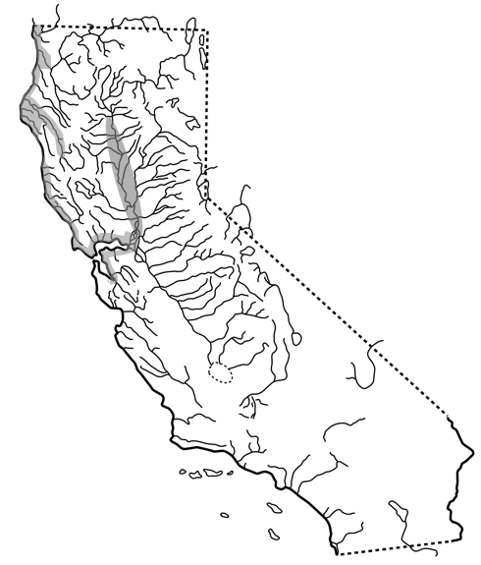

FIGURE 5. Distribution of river lamprey, Lampetra ayresi, in California. Dotted line along the north coast indicates probable distribution.

